**Creating React App**

**REACT**

Vaishnavi

25/7/2025

React is a popular JavaScript library developed by Facebook for building user interfaces, especially single-page applications. It enables developers to create reusable UI components, making web development efficient and scalable.This simple React project demonstrates the basic structure of a React application by displaying a welcome message.

**Objective:**

* Understand how to set up a basic React application.
* Learn the structure of a React component.
* Render a message on the browser using JSX.
* Gain hands-on experience with the **create-react-app** tool.

**Implementation:**

**Step 1: Installing a React App**



**Step 2: Creating a React App**

npx create-react-app myfirstreact

**Step 3: Navigate to the Project Folder**



**Step 4: Open the Project in Your Code Editor**

code .

**Step 5: Modify the App Component**

import './App.css';

function App() {

return (

<div className="App">

<h1>Welcome to the first session of React</h1>

</div>

);

}

export default App;

**Step 6: Run the Application**



This will open your browser at http://localhost:3000, and you’ll see the welcome message rendered.

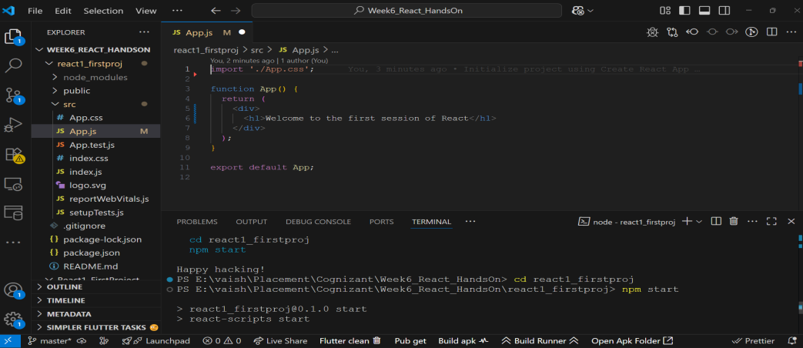

**Output:**

